# Healthy Eating Test 2

Which line of Python code performs the same task as the block code below?

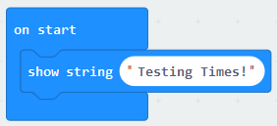

A. display.show(Testing Times!)

B. display.print(“Testing Times!”)

C. display.scroll(Testing Times!)

D. display.scroll(“Testing Times!”)

ANSWER: D

In the selection statement below, which command is missing?

**from** **microbit** **import** *

**while** **True**:

**if** button_a.is_pressed():

display.show(Image.HAPPY)

**____** button_b.is_pressed():

display.show(Image.SAD)

**else**: display.show(Image.YES)

display.clear()

A. if

B. elseif

C. elif

D. else

ANSWER: C

Which piece of software can be used to help write code?

A. Internal Development Environment

B. Integrated Development Environment

C. Input, Develop, Execute

D. Input, Develop, Experiment

ANSWER: B

What is the name of the part of the IDE which allows you to write your own code?

A. Error checker

B. Debugger

C. Code editor

D. Runtime Environment

ANSWER: C

The code below has been developed to show the heart icon. What command is missing?

from microbit ________ *

while True:

display.show(image.HEART)

sleep(2000)

A. Install

B. Initialise

C. Implement

D. Import

ANSWER: D

The code below imports the microbit library. What command should be used to import all functions?

from microbit import ___

A. all

B. #

C. libraries

D. *

ANSWER: D

What is a logic error?

A. An error which produces an unexpected output

B. An error which causes the code to crash

C. An error in the code which the computer doesn’t understand

D. An error which causes the code not to run

ANSWER: A

Which line of code below correct creates a variable called *name* which holds the value *Callum*?

A. name=”Callum”

B. name=Callum

C. “name”=Callum

D. name==”Callum”

ANSWER: A

What would be the code to produce the top row of LEDs in the image below?

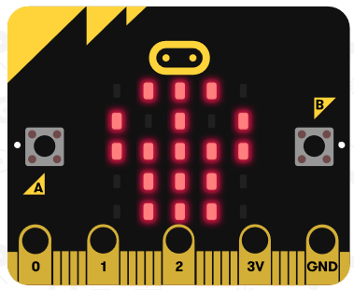

A. “90009:”

B. “90009”

C. “09990”

D. “09990:”

ANSWER: D

In the code below, what is the name of the argument which is passed into the function?

display.show(dotmatrix)

A. display

B. dotmatrix

C. show

D. None of the above

ANSWER: B

A joy pad is used to control a sprite on a computer game. When you press left, the sprite moves left. Which type of statement is being used to move the sprite?



A. Assignment

B. Sequence

C. Selection

D. Iteration

ANSWER: C

In the code below, what will appear on the screen if button a and b is pressed at the same time?

from microbit import *  
while True:  
 if button_a.is_pressed():  
 display.show(Image.HAPPY)  
 else:  
 display.show(Image.HEART)

A. HAPPY Image

B. Nothing

C. Error

D. HEART image

ANSWER: D

What will the program below print?

x = 7

x = "Gareth"

x = “Hello”

x = “Goodbye”

print(x)

A. 7

B. Goodbye

C. x

D. 7 Gareth Hello Goodbye

ANSWER: B

Which of the pins can be used to provide power to a servo?

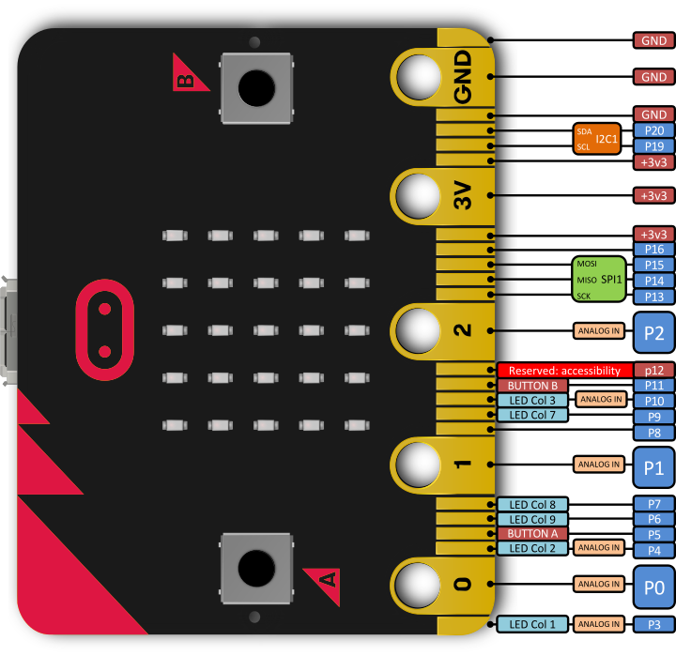

A. 0

B. 3V

C. 1

D. GND

ANSWER: B

Which image will the following code produce on the microbit?

from microbit import *

pattern1 = Image(“90009:”

“09090:”

“00000:”

“99999”

“90909”)

display.show(pattern1)

1. 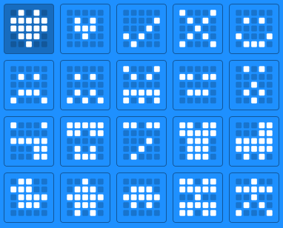
2. 
3. 
4. 

ANSWER: C

Sometimes it is useful to pause a program before the next image or text string appears on the screen. Which function can you use to do this?

A. Pause

B. Sleep

C. Stop

D. Delay

ANSWER: B

How many times will the while loop below run?

**from** **microbit** **import** *

**while** **True**:

**if** button_a.is_pressed():

display.show(Image.HAPPY)

**elif** button_b.is_pressed():

display.show(Image.SAD)

**else**: display.show(Image.YES)

display.clear()

A. Until while True changes to False

B. Until buttons A and B are pressed together

C. Once

D. None

ANSWER: A

Python allows you to adjust the brightness of the LEDs on the microbit. Which number would be used to display an LED at its’ maximum brightness?

A. 10

B. 5

C. 9

D. 1

ANSWER: C

What will the code below output?

Num1=”2”

Num2=”3”

print(“Num1”+”Num2”)

A. 5

B. Num1Num2

C. Num1 Num2

D. 23

ANSWER: B

Identify which line contains iteration.

1. from microbit import *

total = 0

1. while True:
2. if button_a.is_pressed():
3. total = total + 1

sleep(100)

display.scroll(total)

A. 01

B. 02

C. 03

D. 04

ANSWER: B